**Validity extension**

Tenders with valid bid validity should be listed under list of bid validity extension sub-menu

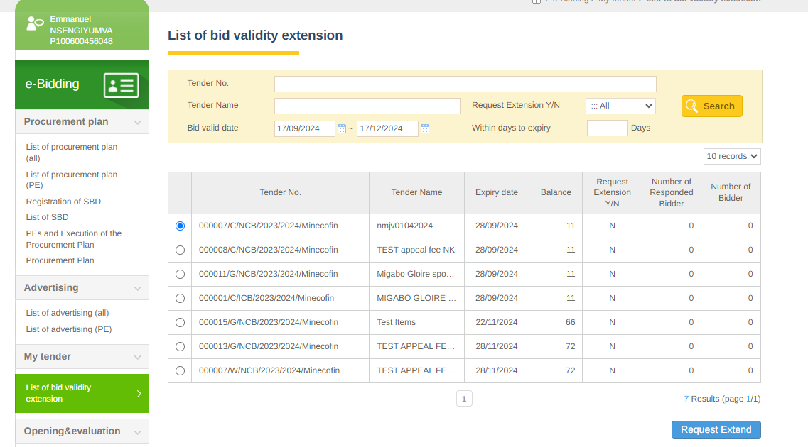

Days to extend should not exceed 60 days

